SRS Document for Waslah

📄 Software Requirements Specification (SRS)

Waslah – Multi-Store E-commerce Platform

1. Introduction

1.1 Purpose
This document defines the functional and non-functional requirements for Waslah, a multi-store e-commerce platform similar to Salla.
The document is intended for:
- Product owners
- UI/UX designers
- Backend & frontend developers
- QA engineers
- Business stakeholders

1.2 Scope
Waslah enables merchants to:
- Create and manage online stores
- List and sell products
- Manage orders, payments, shipping, and customers
Customers can browse multiple stores and place orders through a unified platform.
The platform supports web and mobile applications.

2. Overall Description

2.1 Product Perspective
Waslah is a cloud-based SaaS platform consisting of:
- Merchant Dashboard
- Admin Panel
- Customer Storefront
- Payment & Shipping Integrations
- API Layer
Architecture follows a modular, scalable design.

2.2 User Classes & Personas
User Type | Description
Platform Admin | Manages platform settings, approvals, fees
Merchant | Owns a store, lists products, fulfills orders
Store Staff | Manages orders/products under permissions
Customer | Browses stores and purchases products
Support Agent | Handles disputes and customer support

2.3 Operating Environment
- Web: Chrome, Safari, Edge
- Mobile: iOS & Android
- Backend: Cloud-based (AWS / GCP / Azure)
- Database: Relational + NoSQL (hybrid)

2.4 Constraints
- Must comply with Saudi e-commerce regulations
- Must support Arabic (RTL) and English
- Must integrate with local payment gateways
- High availability (99.9% uptime target)

3. System Features (Functional Requirements)

3.1 Authentication & User Management

Description
Users can register, log in, and manage their profiles securely.

Functional Requirements
- Email & phone registration
- OTP verification
- Role-based access control
- Password reset
- Two-factor authentication

3.2 Merchant Store Management

Description
Merchants can create and customize their own stores.

Functional Requirements
- Store creation wizard
- Custom domain support
- Theme & branding customization
- Store status (active / paused)
- SEO settings per store

3.3 Product Management

Functional Requirements
- Create/edit/delete products
- Product variants (size, color, etc.)
- Inventory tracking
- SKU management
- Bulk import/export (CSV)
- Digital & physical products

3.4 Order Management

Functional Requirements
- Order creation & tracking
- Order statuses:
  - Pending
  - Paid
  - Processing
  - Shipped
  - Delivered
  - Cancelled
- Partial refunds
- Order notes (internal)

3.5 Payment System

Functional Requirements
- Multiple payment gateways
- Split payments (platform commission)
- COD support
- Automatic invoicing
- Refund handling

3.6 Shipping & Fulfillment

Functional Requirements
- Multiple shipping providers
- Real-time shipping rates
- Order tracking links
- Shipping rules by region
- Manual fulfillment option

3.7 Customer Experience

Functional Requirements
- Browse stores and products
- Product search & filters
- Cart & checkout
- Order history
- Wishlist
- Reviews & ratings

3.8 Admin Panel

Functional Requirements
- Merchant approval
- Commission management
- Platform analytics
- Store suspension
- Dispute management
- Content moderation

4. External Interface Requirements

4.1 User Interface
- Responsive design
- RTL/LTR support
- Accessible (WCAG AA)
- Fast load times (<2s for key pages)

4.2 API Interfaces
- REST / GraphQL APIs
- Webhooks for:
  - Orders
  - Payments
  - Shipping updates
- OAuth2 authentication

4.3 Third-Party Integrations
- Payment gateways
- Shipping carriers
- SMS & Email services
- Analytics tools

5. Non-Functional Requirements

5.1 Performance
- Handle 10,000+ concurrent users
- Page load < 2 seconds
- API response < 500ms (average)

5.2 Security
- Encrypted data at rest & in transit
- PCI-DSS compliance
- Role-based permissions
- Activity logs

5.3 Scalability
- Horizontal scaling
- Microservice-ready architecture
- CDN support

5.4 Reliability & Availability
- 99.9% uptime
- Automated backups
- Disaster recovery plan

5.5 Localization
- Arabic (default)
- English
- Multi-currency support

6. Assumptions & Dependencies

Assumptions
- Merchants manage their own content
- Platform takes commission per order
- Internet connectivity is available

Dependencies
- Payment providers uptime
- Shipping API availability
- SMS/email service reliability

7. Out of Scope (Initial Phase)
- Native POS hardware
- Marketplace bidding system
- AI product recommendations (Phase 2)

8. Future Enhancements
- Mobile apps
- Subscription products
- Advanced analytics
- AI fraud detection
- Plugin marketplace

9. Acceptance Criteria
Feature: Create Product
- Given merchant is logged in
- When product data is valid
- Then product is saved and visible in store

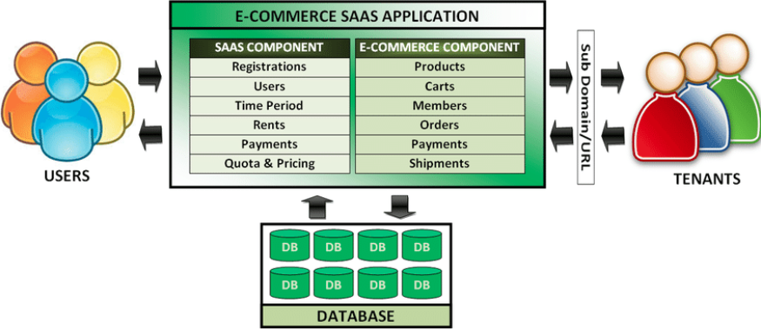
Waslah – Technical Architecture (Multi-Store Platform)
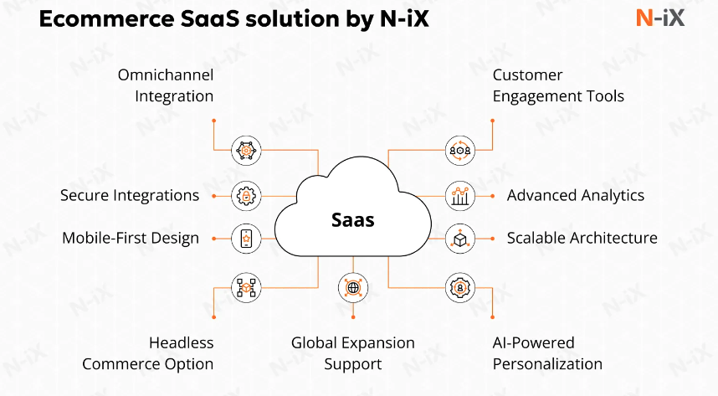
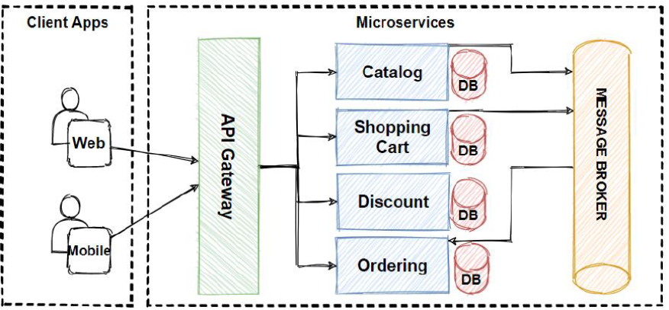

1 High-Level Architecture Overview

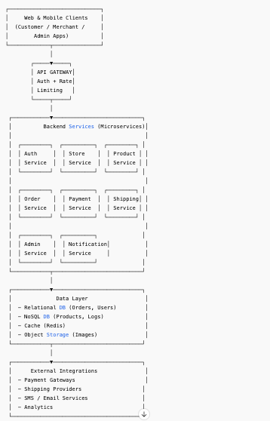

2 Core Components Explained (No Hand-Waving)

🖥️ Frontend Layer
- Customer Storefront (Web / Mobile)
- Merchant Dashboard
- Admin Panel
Tech options
- Web: React / Next.js
- Mobile: Flutter or React Native
- Admin: React + Ant / MUI

🚪 API Gateway
Single entry point:
- Authentication
- Rate limiting
- Request routing
- Logging
Tech
- Kong / AWS API Gateway / NGINX

⚙️ Backend Services (Multi-Tenant)
Each service is tenant-aware (Store ID everywhere).
Service | Responsibility
Auth Service | Login, roles, permissions
Store Service | Store setup, domains, themes
Product Service | Products, variants, inventory
Order Service | Orders, refunds, statuses
Payment Service | Payments, commission split
Shipping Service | Rates, labels, tracking
Notification Service | SMS, email, push
Admin Service | Platform control & moderation

3️ Data Layer Design (Critical for Scaling)

Databases
- PostgreSQL
  - Users
  - Orders
  - Payments
- MongoDB
  - Products
  - Store settings
- Redis
  - Sessions
  - Cart
  - Rate limits
- Object Storage
  - Product images
  - Invoices
🔑 Every table/document includes store_id
(no store leaks = no lawsuits)

4️ External Integrations

Payments
- Local gateways
- Split payments (merchant + platform commission)
- Webhooks → Order Service

Shipping
- Rate calculation
- Label creation
- Tracking updates

Notifications
- SMS (OTP, order updates)
- Email (invoices, confirmations)

5️ Data Flow Example (Checkout)
- Customer clicks Pay
- API Gateway → Order Service
- Order Service → Payment Service
- Payment Gateway confirms payment
- Webhook → Payment Service
- Order status updated
- Notification Service sends confirmation
- Merchant dashboard updates in real time
Smooth. Auditable. No mystery states.

6️ Deployment & Infrastructure

Recommended Setup
- Docker + Kubernetes
- CI/CD (GitHub Actions / GitLab)
- CDN for storefront assets
- Load balancer
- Auto-scaling groups

Environments
- Dev
- Staging
- Production

7️ Security Architecture
- HTTPS everywhere
- JWT + Refresh tokens
- RBAC (Admin / Merchant / Staff)
- Webhook signature verification
- Audit logs (immutable)

